

**Please state Index Number:**

|  |  |  |  |  |
| --- | --- | --- | --- | --- |
| **Student Name:** | | **Orifjonov Ibrohim** | | |
| **Student Number:** | | **B2000986** | | |
| **Course:** | |  | | |
| **Module Code and Title:** | |  | | |
| **Module Leader:** | |  | | |
| **Module Tutor:** | |  | | |
| **Assessment:** | |  | | |
| **Due Date:** |  | | **Date Submitted:** |  |
| **Weighting within Module:** | |  | | |
| **ALL MARKS ARE PROVISIONAL AND ARE SUBJECT TO CHANGE UNTIL CONFIRMED BY THE EXTERNAL EXAM BOARD** | | | | |
| **Comments from Internal Examiner (Name):** | | | | |
| **Strengths:** | | | | |
| **Weaknesses:** | | | | |
| **Areas of Improvement:** | | | | |
| **Provisional Mark out of 100:** | | |  | |
| **ALL MARKS ARE PROVISIONAL AND ARE SUBJECT TO CHANGE UNTIL CONFIRMED BY THE EXTERNAL EXAM BOARD** | | | | |

Table of Contents

Task 1: Structure and Content of Webpage 3

Task 2: Style your Webpage 4

Task 3: Building a 3x3 image Gallery from a JSON Object 5

Task 4: Create an Interactive Image Carousel from a JSON Object 6

Task 5: Website Testing and Validation 7

# Task 1: Structure and Content of Webpage

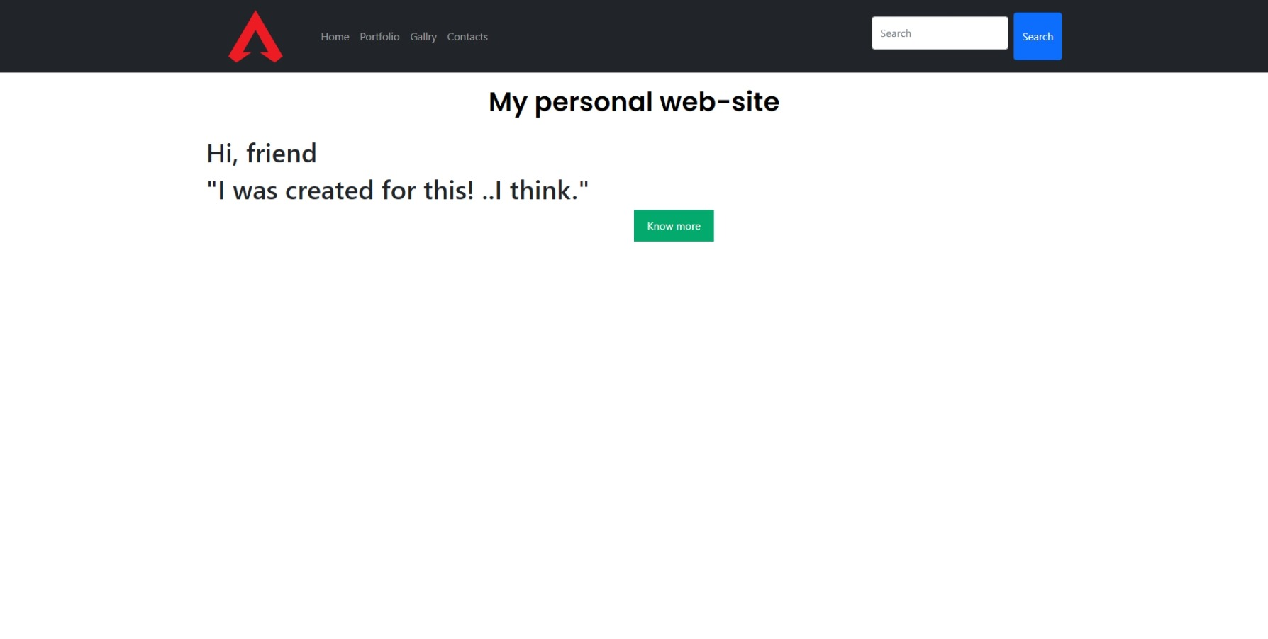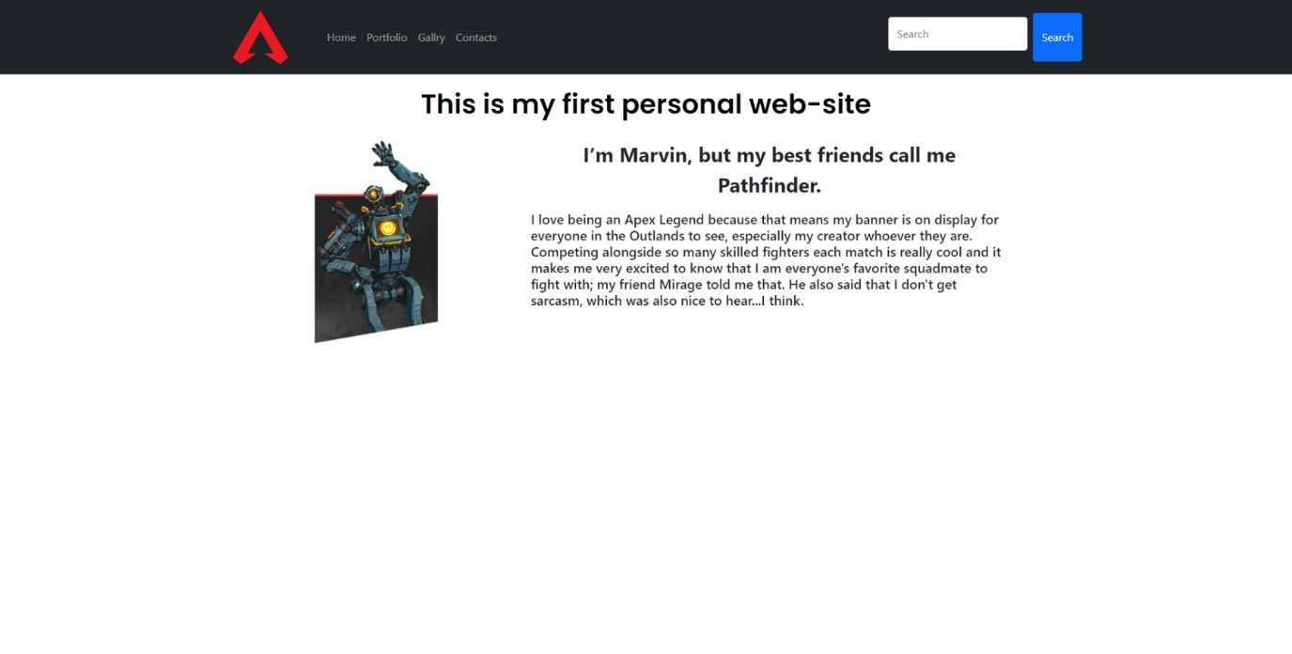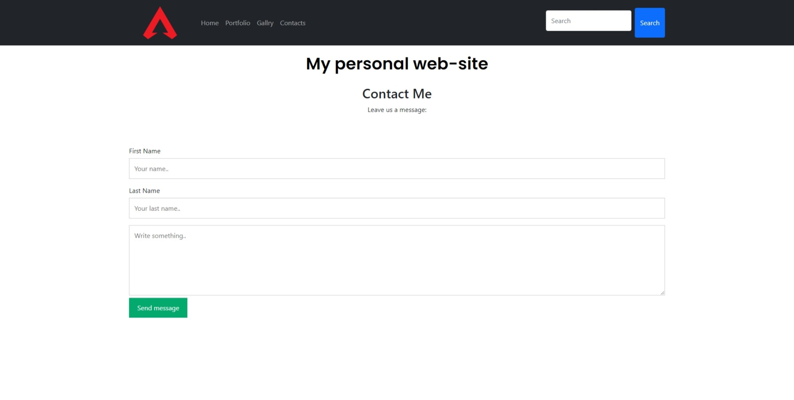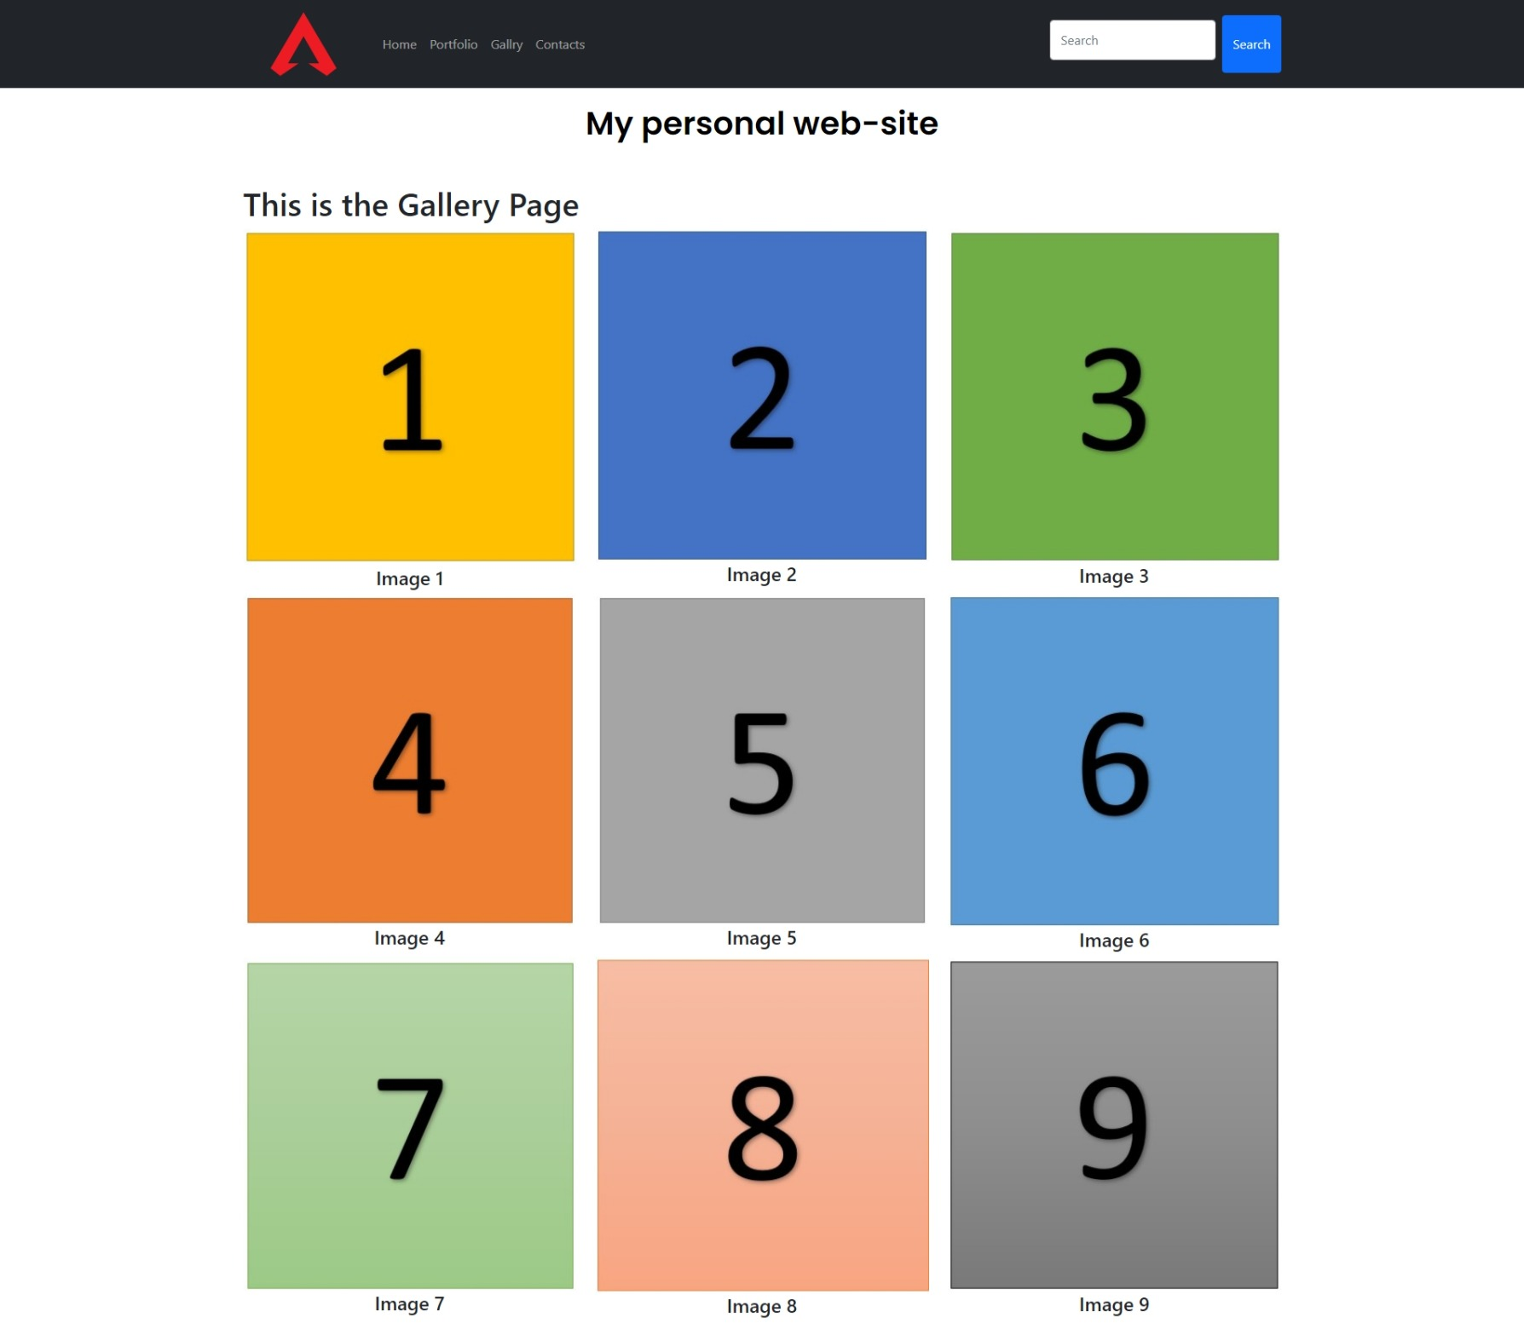

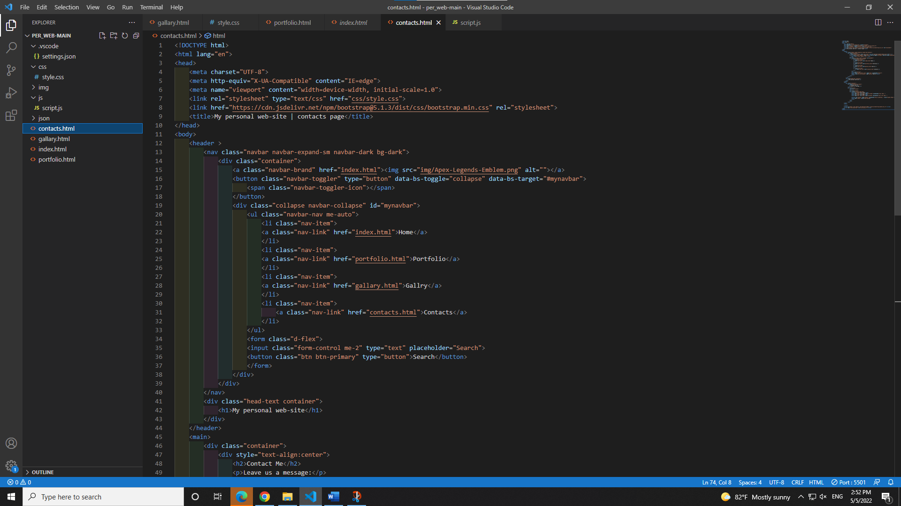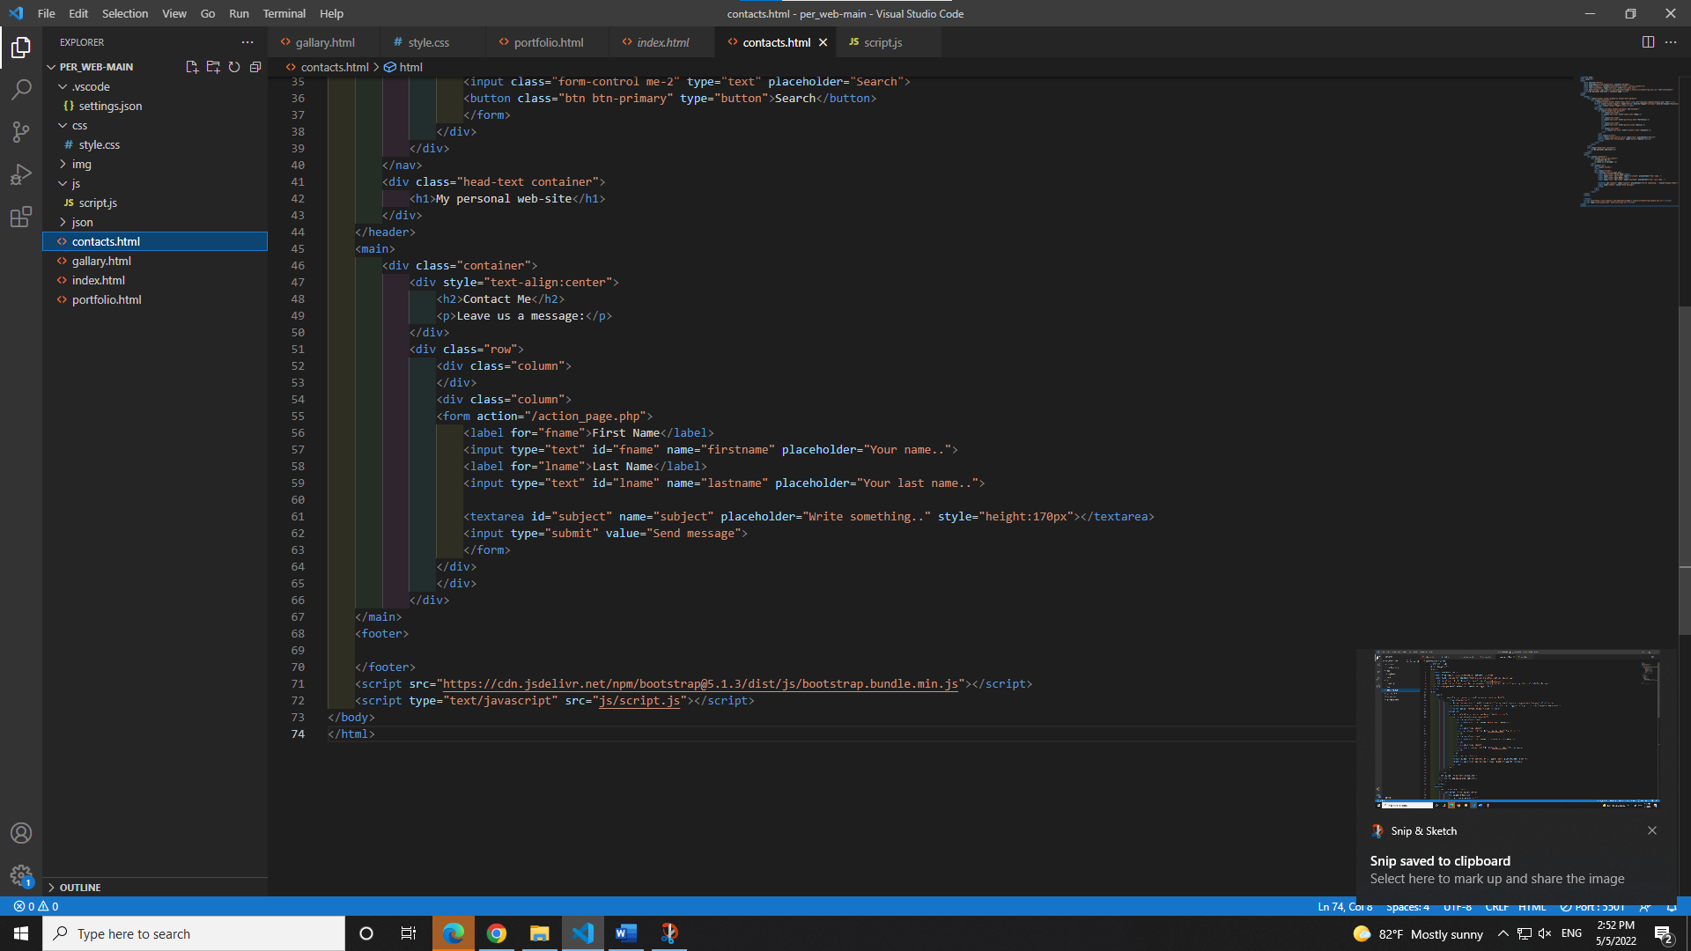

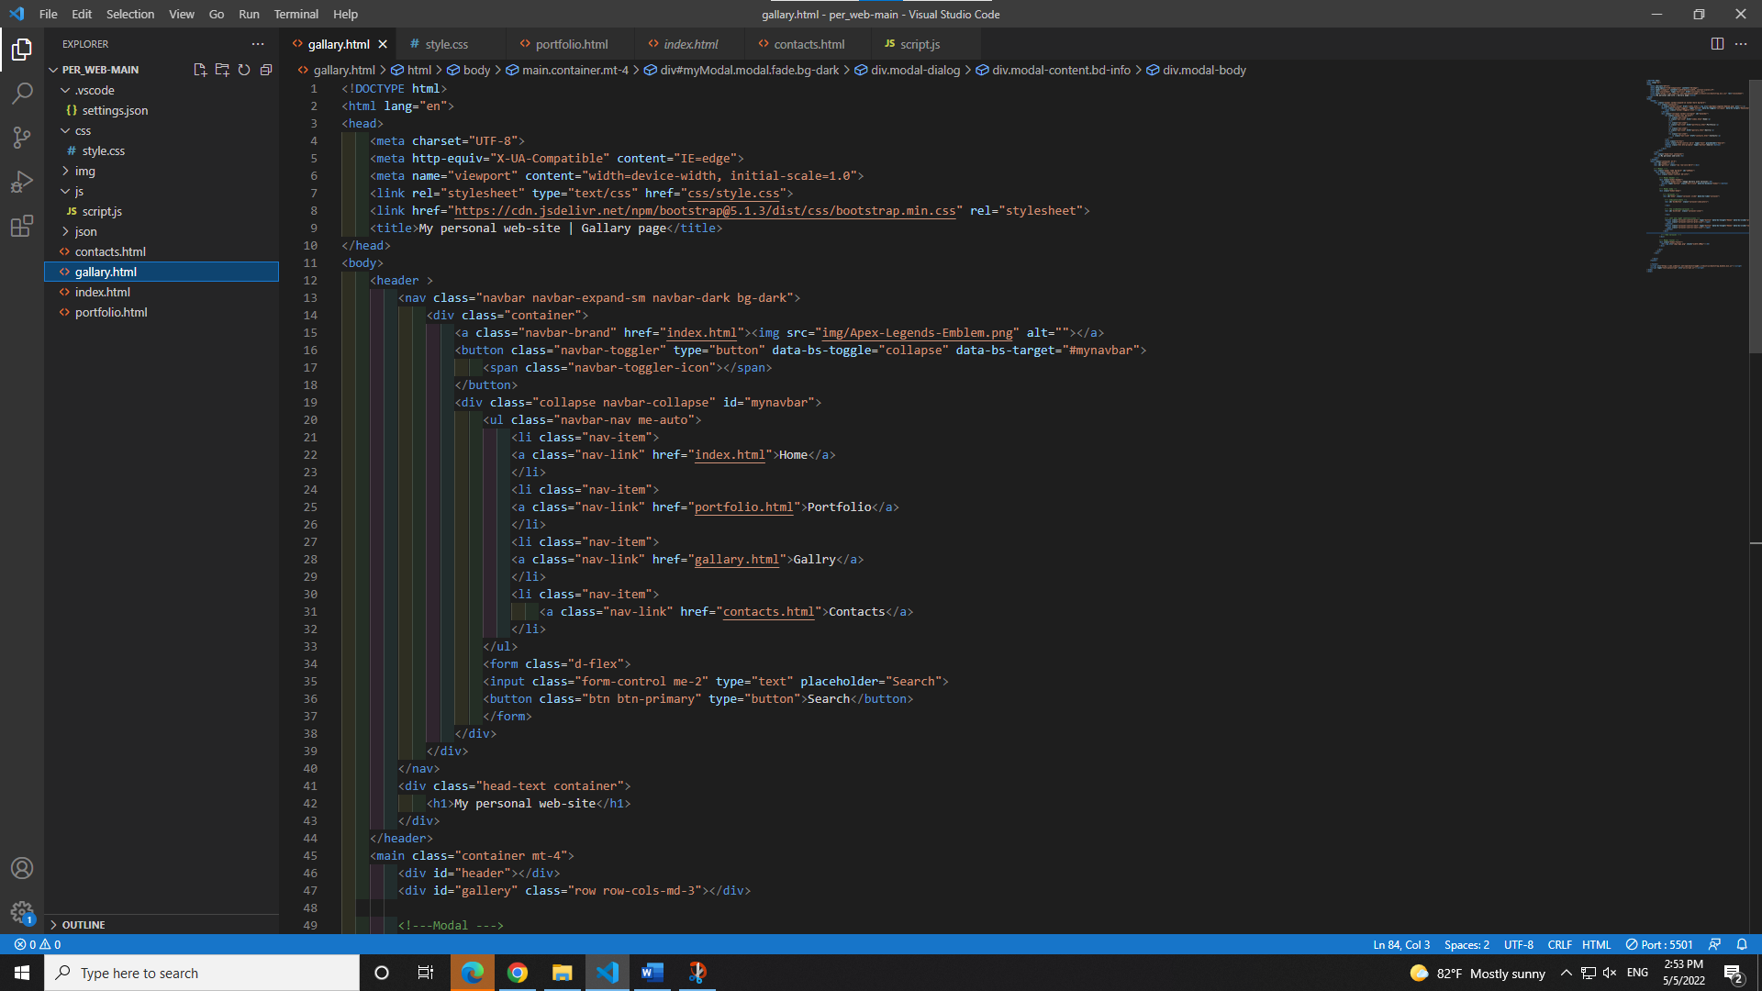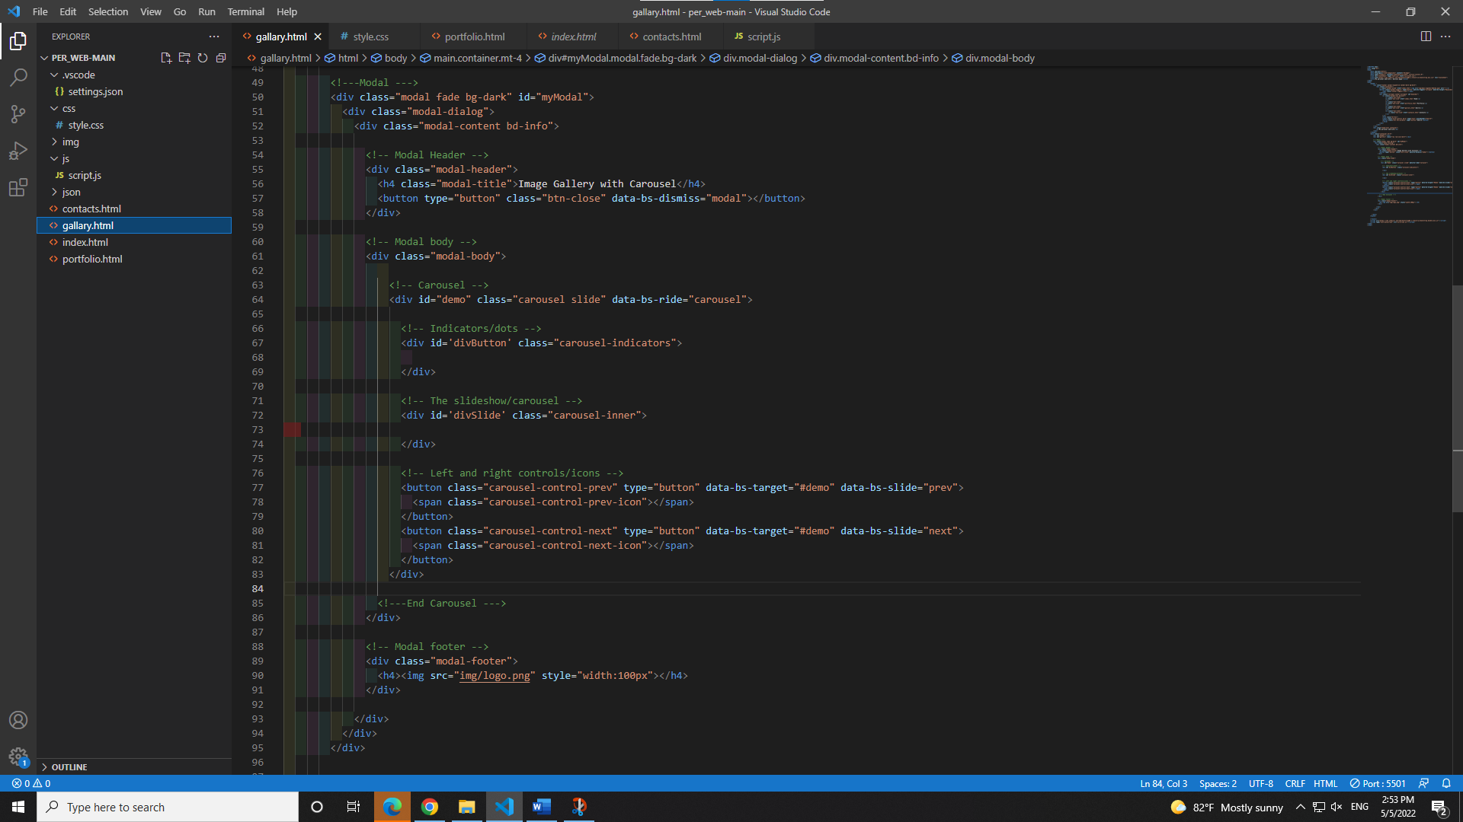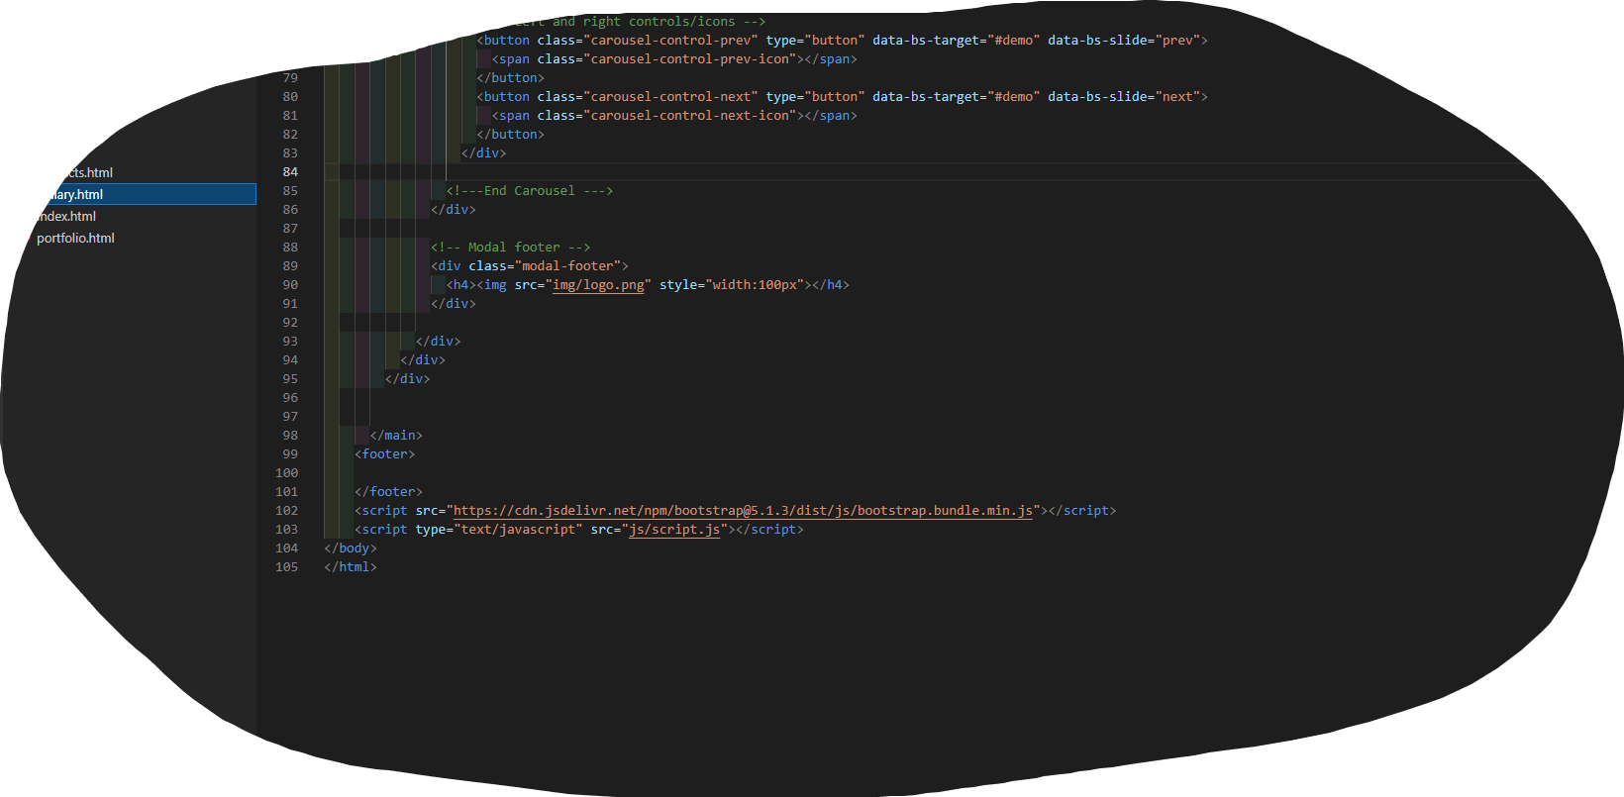

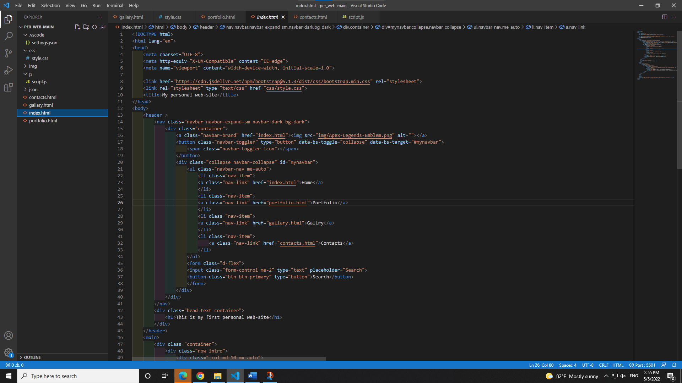

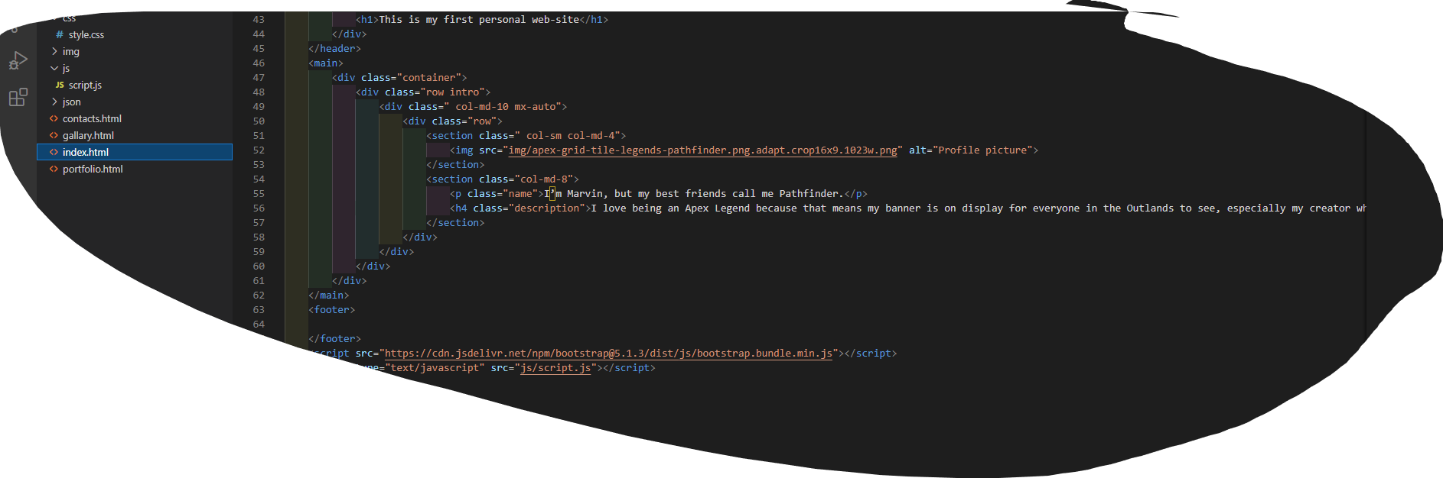

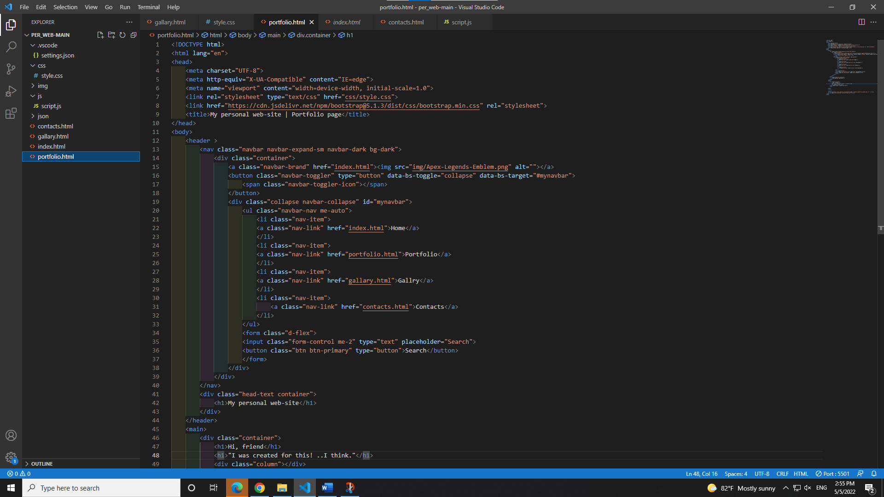

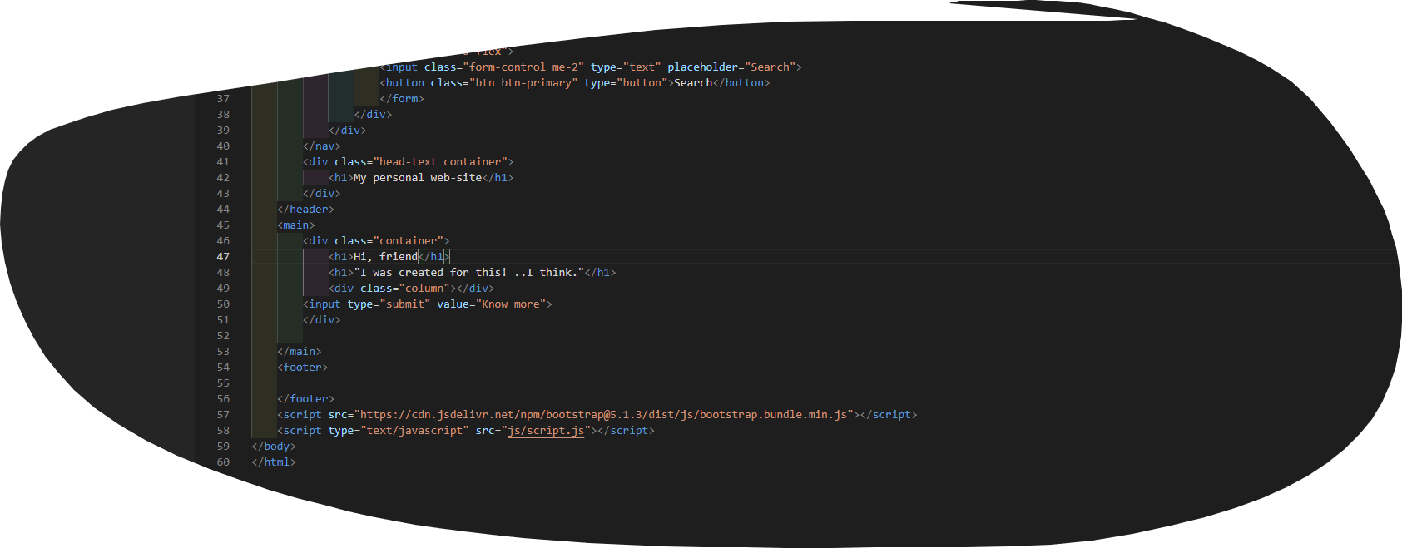

# Task 2: Style your Webpage

# 

# Task 3: Building a 3x3 image Gallery from a JSON Object

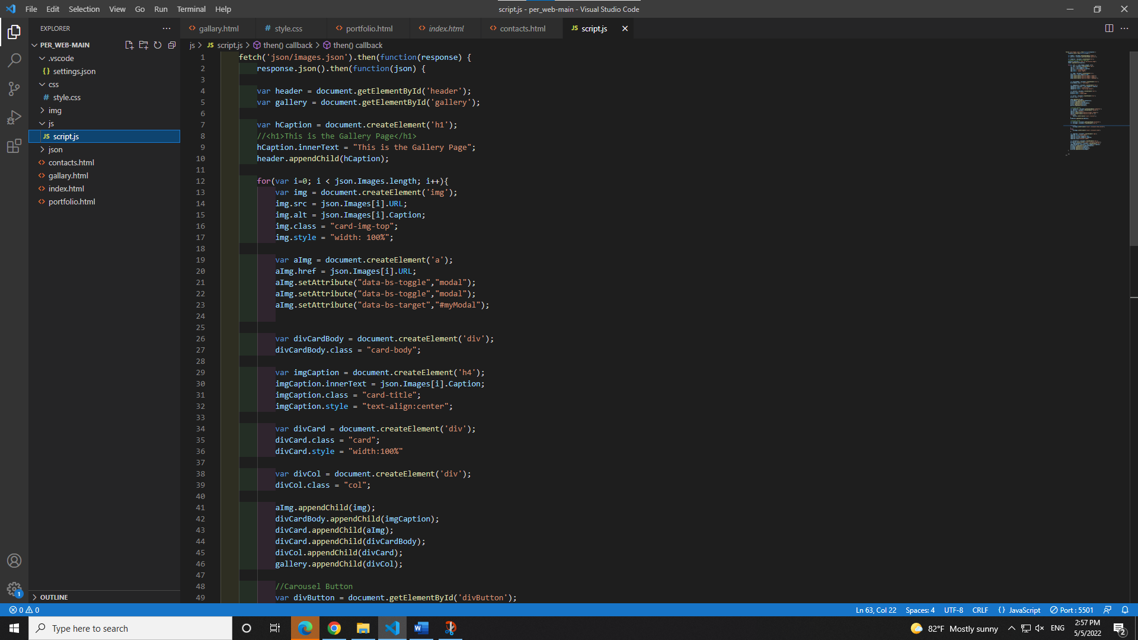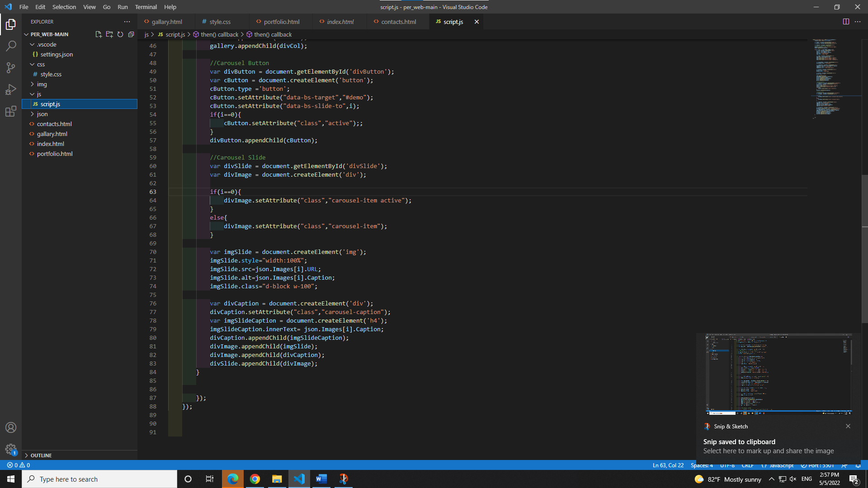 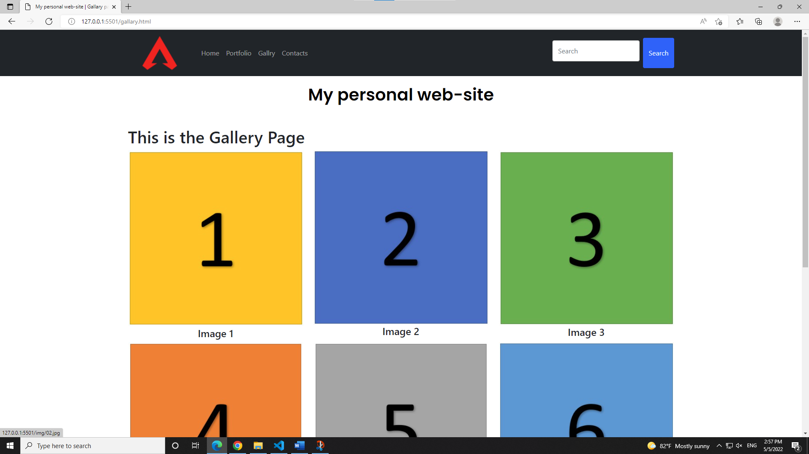

# Task 4: Create an Interactive Image Carousel from a JSON Object

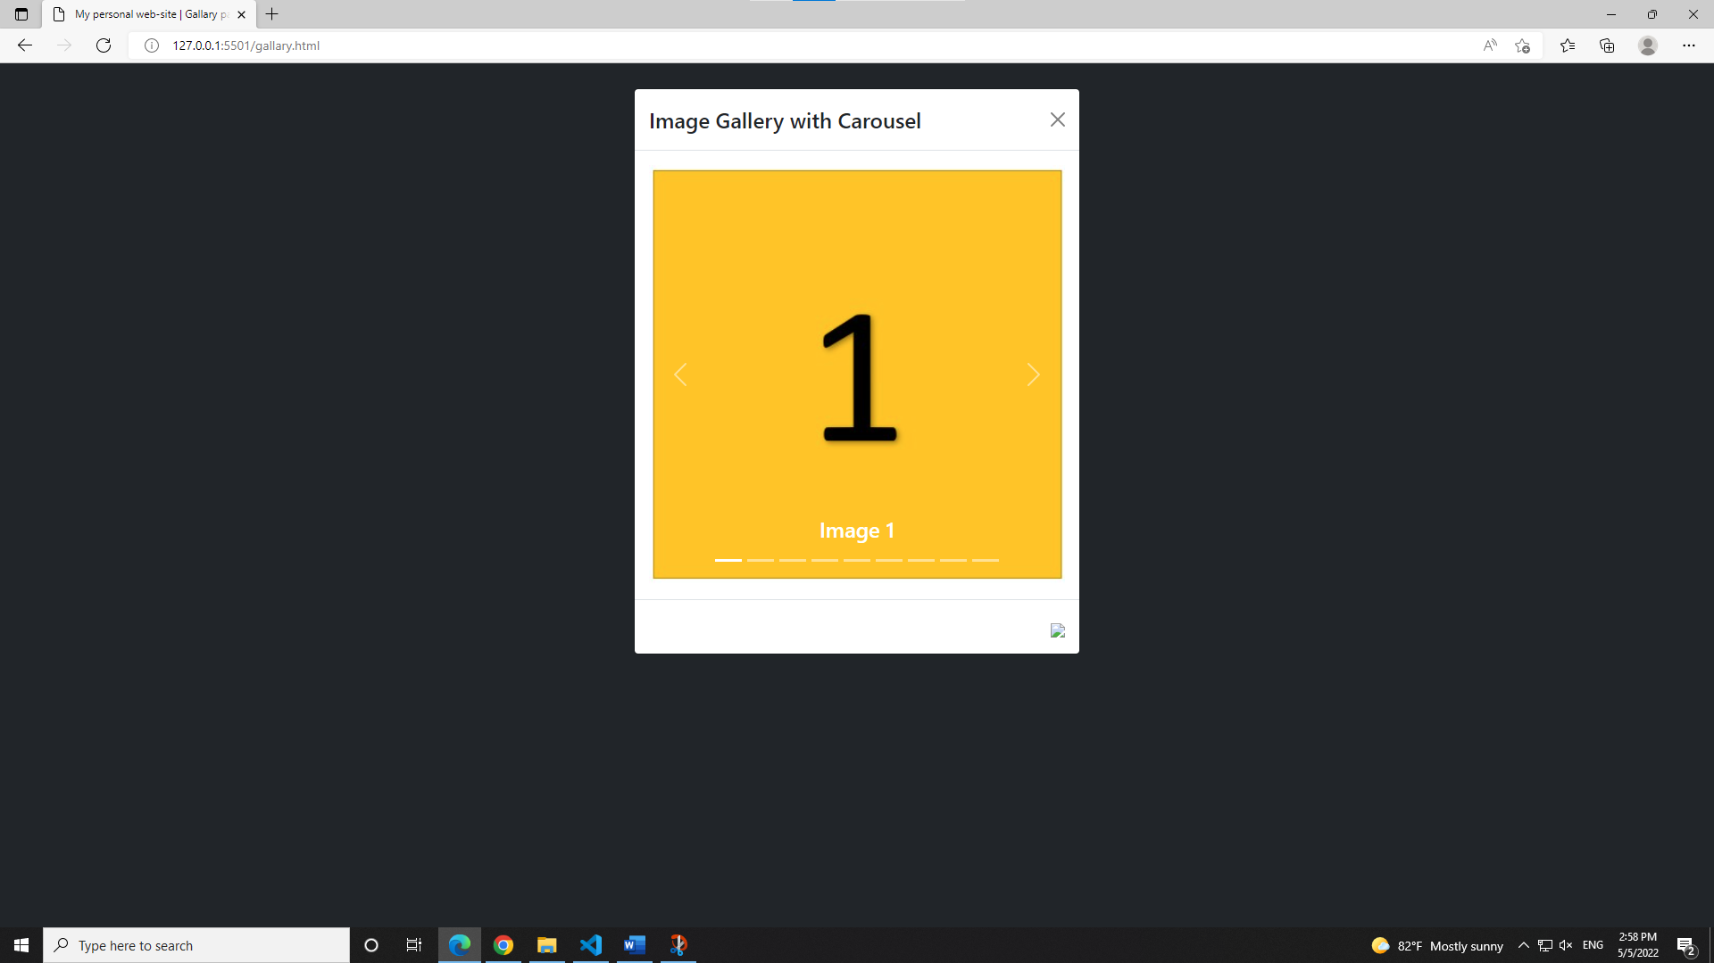

# Task 5: Website Testing and Validation

